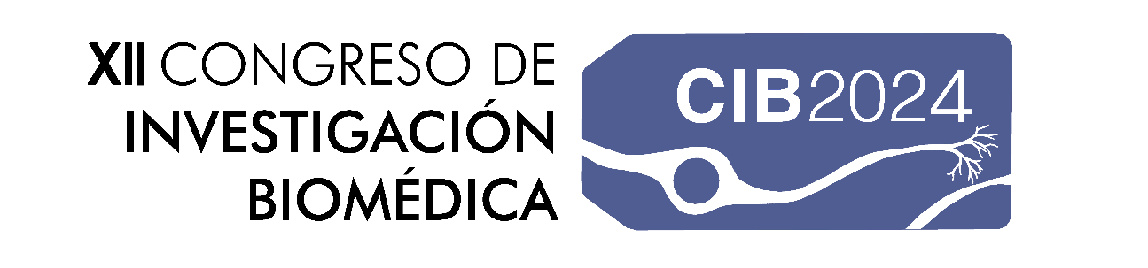

ABSTRACT SUBMISSION FORM
Deadline: 4th January 2024

PROYECT TITLE: Click here to start writing.

RESPONSIBLE AUTHOR(s): Click here to start writing.

- UNIVERSITY/INSTITUTION: Click here to start writing.
- LEVEL OF EDUCATION: Click here to start writing.
- FACULTY (if applicable): Click here to start writing.
- CONTACT EMAIL: Click here to start writing.

CATEGORÍA DE LA OBRA:

☐ PLASTIC ARTS
☐ SCENIC ARTS

TITLE
Author(s)
Institution

DESCRIPTION OF THE PROYECT (100-300 words)
Click here to start writing.

SKETCH (IF APPLICABLE)
Click here to start writing.

